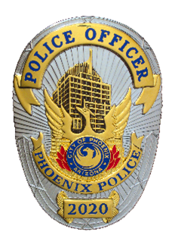

Phoenix Police Department
Public Affairs Bureau
620 West Washington Street, Phoenix, Arizona 85003

MEDIA ADVISORY

Date/Time: November 18, 2025, at about 5:19 a.m.
Incident: 2025-1667040
Location: 2600 North 71st Avenue
Victim: Jessica Guzman, 32-year-old, deceased
Suspect: Josue Barreras Anaya, 36-year-old, booked G219351

Suspect Drives Deceased Victim to Police

(November 19, 2025) Early Tuesday morning, 36-year-old Josue Barreras Anaya drove the deceased victim to a west Phoenix police station to notify officers. Barreras Anaya was taken into custody and later booked into jail for 1st Degree Murder.

Just after 5:00 a.m., Phoenix patrol officers were flagged down by Barreras Anaya in the parking lot of Maryvale Precinct located at 6180 West Encanto Boulevard. The Barreras Anaya told officers he had shot his girlfriend and that she was in the back of his truck. Officers located an adult female victim in the bed of the truck suffering from at least one gunshot wound. Phoenix Fire responded to the precinct and pronounced the victim deceased.

Patrol officers went to the suspects residence located in the area of 2600 North 71st Avenue, and ensured no other victims were inside. No one was located inside the residence. Detectives responded to both scenes and took over the investigation. Barreras Anaya was booked into Maricopa County Jail for 1st Degree murder.

Further details concerning this incident are part of an ongoing investigation.

Sergeant Brian Bower
Public Affairs Bureau

